ArcGIS for Maritime: Charting

## Tutorial

### Tutorial purpose

The purpose of this tutorial is to guide you through the basic process of importing, creating and exporting S-57 products in ArcGIS for Maritime: Charting. You will learn how to ingest an S-57 file into the Esri geodatabase, create an S-57 product in the Esri product management system, and export an S-57 back out of the geodatabase.

### Tutorial Components

The production environment consists of two major components: the Nautical Information System (NIS) and the Product Library. The NIS is a centralized data storage repository, which means that all data is imported or otherwise created there. Once the appropriate data is compiled or loaded to the NIS, it can be continually maintained there, and navigational products and their updates can be exported from it as needed. One of the benefits of the NIS database is that multiple-scale data can be stored in one central location for easy editing access. Nautical products, such as ENCs, can then be extracted directly from the NIS. The ***TUTORIAL_NIS.gdb*** serves as the NIS for this tutorial.

The second component of the ArcGIS for Maritime: Charting production system is the product library. The product library is the management hub for your portfolio of products. The product library has extensive metadata about the products, such as the geographic area of interest, scale, and dataset information. The ***TUTORIAL_PRODUCT_LIBRARY.gdb*** serves as the product library for this tutorial.

### Configuration

Before getting started with the tutorial there are a couple of configuration settings that must be applied. They are only set once, but can be changed at any time if necessary. These settings include:

* Defining the Product Library – This step defines the location of the database that will be used as the Product Library.
* Defining the NIS – This sets the location of the database where all of your nautical data is stored, edited and exported from.
* Setting your Agency/FIDS – This provides the system with the information required to build unique LNAM values for each feature in the database, as mandated by S-57.

Once these 3 simple steps have been completed, you are ready to begin creating products.

### Defining the Product Library

You will use the ***TUTORIAL_PRODUCT_LIBRARY.gdb*** provided with the tutorial as your product library workspace. To set this workspace as your product library, complete the following steps:

1. Start ArcMap.
2. From the main menu, click Customize > Production > Product Library.

Tip:

If the Product Library command is not enabled, you may need to enable the Production Mapping extension by clicking Customize > Extensions and checking the check box for Production Mapping. At this time, you may want to ensure that the Maritime Charting extension is also enabled.

1. Right-click Product Library and click Select Product Library.

The Choose Product Library Workspace dialog box appears.

1. Navigate to the folder that contains the ***TUTORIAL_PRODUCT_LIBRARY.gdb***.
2. Select the ***TUTORIAL_PRODUCT_LIBRARY.gdb*** product library database by clicking on it once.
3. Click Open.

### Defining the NIS

1. In the ***Product Library*** window, expand the Product Library treeview to the ***ENC*** class node.

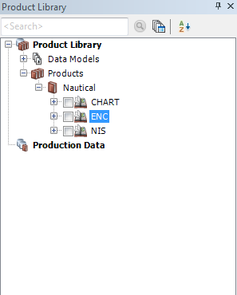

1. Right-click the ***ENC*** node, then click Properties.

The ***Class Properties*** dialog box appears.

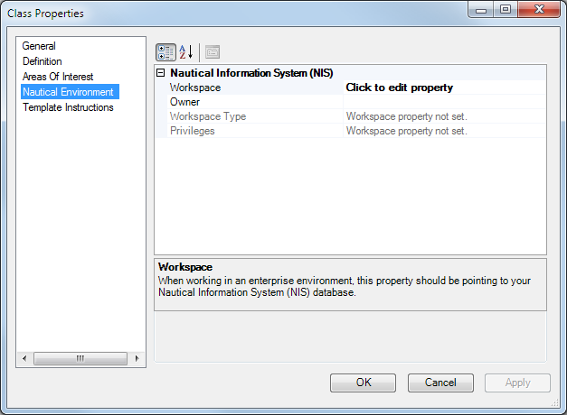

1. Click **Nautical Environment** in the pane on the left.
2. In the Nautical Information System (NIS) section, click the **Click to edit property** cell next to Workspace and click the ellipsis button (...) that appears.
3. Navigate to the location of the ***TUTORIAL_NIS.gdb***.
4. Select the ***TUTORIAL_NIS.gdb*** product library database by clicking on it ONCE.
5. Click Open.

The NIS workspace location is added to the property.

1. Click OK.

### Setting your Agency/FIDS

1. On the main menu, click Customize > Production > Production Properties.

The ***Production Properties*** dialog box appears.

1. Click **Nautical Properties** in the pane on the left.
2. Click the cell next to **Agency/FIDS Property**.
3. Click the ellipsis (...) button.

The ***Agency/FIDS Properties*** dialog box appears.

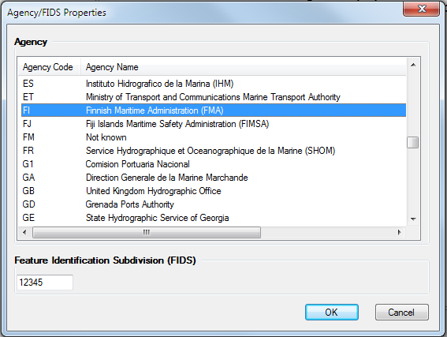

1. Choose the agency code from the Agency Code list.
2. Type the **Feature Identification Subdivision (FIDS)** value.

The FIDS value can be any number between 1 and 65534, and is used for generating a unique LNAM for features. Only numbers are accepted.

1. Click OK.

# Exercises

Now that you have completed the basic steps required to begin using ArcGIS for Maritime: Charting as a production system, you are ready to begin creating S-57 products. This tutorial consists of 3 short exercises, each intended to give you some general understanding of how data flows through the system.

First, you will export a New Edition of an ENC product that was already created in the tutorial product library for you. Then, you will create a new product in the product library and export a New Edition. Lastly, you will import an S-57 cell into the NIS, create a new product in the product library, and export it back out to S-57.

### Exercise 1: Exporting an ENC product

When you have products managed by the Product Library, you can quickly export New Editions and Updates. When you use the Export Nautical Product wizard, data is extracted from the NIS database and mapped to the S-57 transfer standard.

For the purposes of this tutorial, you will be exporting a New Edition of an ENC product that already exists in the provided ***TUTORIAL_PRODUCT_LIBRARY.gdb***.

1. In the ***Product Library*** window, click the ***ENC*** class node to expand it.
2. Click the ***Tutorial*** Series node to expand it.
3. Right-click on the ***US5NY1DM*** product node and click **Export Nautical Product...**

The ***Export Information*** dialog box area appears.

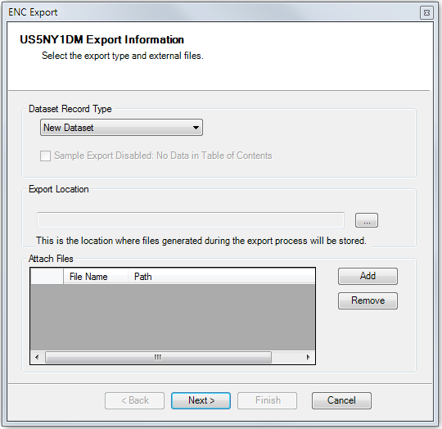

1. Click the **Dataset Record Type** drop-down arrow and choose **New Edition**.
2. Click the ellipsis button (...) in the **Export Location** area and browse to the location where you want to store your export package.
3. Click Next.

The ***Export Metadata*** page appears.

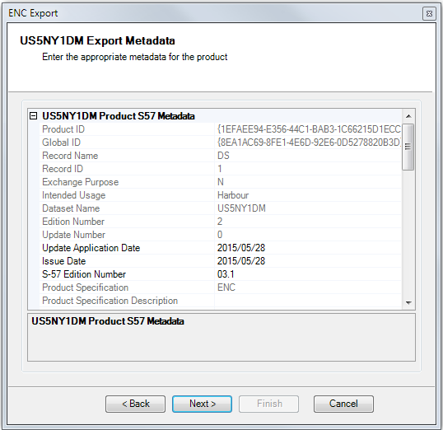

Metadata info:

On the Export Metadata wizard page, you can view and modify your product's metadata values before export. There are two nodes in the Metadata Viewer: Product and Instance. The Product-level metadata contains the DSID (Dataset Identification) and DSSI (Dataset Structure Information) metadata fields. The Instance-level metadata contains the DSPM (Data Set Parameters) metadata fields. The left side of the view shows the metadata fields and the right side shows their values. You can input new values in the fields that are not disabled.

The metadata options are different depending on the task you are performing. For example, if you are exporting a New Edition file, you can set the Vertical Datum; however, if you are exporting an Update file, you cannot change this value.

For the purpose of this tutorial, it is not necessary to modify any of the metadata.

1. Accept the defaults and click Next.

The ***Metadata summary*** wizard page appears.

1. Click Finish.

The ***Exporting*** progress dialog box appears showing the export process.

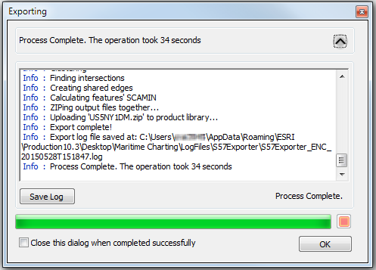

1. Click OK to close the progress dialog box.

You have now created an S-57 export package.

When you ran the Nautical New Product wizard, metadata about the product- the scale, extend and cell header information - was pulled from the product library, while the features were extracted from the NIS, and the two sets of information were combined to generate the S-57 file.

You can browse to the Export Location to access the export package. The package is also zipped up and stored in the product library.

### Exercise 2: Creating a new ENC product and exporting a New Edition

In the previous exercise, you learned how to export a new edition of an already existing product. But what if you want to create a brand new product? Now that you understand how to export an ENC from the Product Library, you will be introduced to creating a new product, which you can then immediately export. Creating a product is only done once, prior to exporting the first edition of the product. Once the product is created, you can use the Export Nautical Product wizard to export New Editions and Updates without having to re-create the product.

To create a new product in ArcGIS for Maritime: Charting, follow the instructions below, which guide you through the New Nautical Product wizard.

1. Right-click the ***Tutorial*** series node under the ***ENC*** class node and click **New Nautical Product**.

The ***Overview*** page of the **New Nautical Product** wizard appears.

1. Click Next.

The ***Area of interest selection*** wizard page appears.

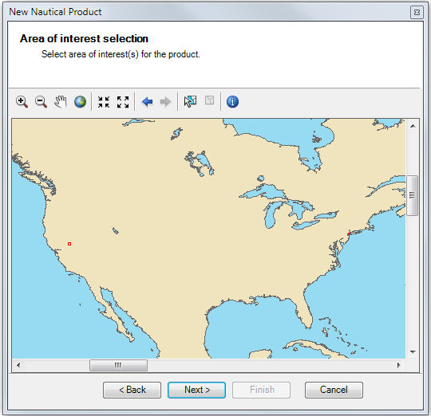

One of the first things you need to do when creating a new product is select a feature that will represent the extent of the product. On this wizard page, you can select, unselect, identify, zoom in, zoom out, and pan.

The product you will be creating is over Lake Tahoe in California in the Western United States. You can see the Areas of Interest (AOIs) that are already available as red polygon outlines. This tutorial comes with two preloaded AOIs. In a later step, you will learn how you can easily add more AOIs.

1. If necessary, click the **Zoom In**  button and drag a box around the area where your AOI features are located – near Lake Tahoe in California, USA.
2. Click the **Select** button  and drag a box around the AOI features to select them.
3. Click Next.

The ***S-57 Product name definition*** dialog appears.

In this page of the New Nautical Product wizard, you will define the S-57 cell name, which is a combination of the Producing Agency, the cell’s Intended Usage, and a 5 character Product Identification value. When the product is created, the dataset name value you define is used as the product name in the Product Library tree view.

1. For **Producing Agency,** leave the default. The default value represents the Agency setting you defined in the nautical properties earlier in the tutorial.
2. Click the **Intended Usage** drop-down arrow and choose your S-57 product's intended usage value. For this product, the Intended Usage is ***5 – Harbour***.
3. Type the remaining five characters of your S-57 product's dataset name in the **Product Identification** field.

Your S-57 Product name definition page should look similar to the following image:

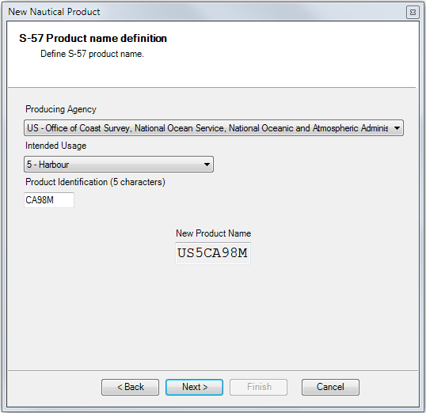

1. Click Next.

The ***Product Metadata*** dialog appears.

The last thing you need to do is define your product’s metadata. Most of this information is automatically populated; however, some of the metadata can be edited in this wizard page if you want to change it. When the product is created, the metadata information is stored in the Product Library, and can be accessed at any time using a Metadata Viewer tool.

1. Click Next.
2. Click Next on the ***Summary*** page.
3. Click Finish.

A progress dialog box appears with the status of the creation process.

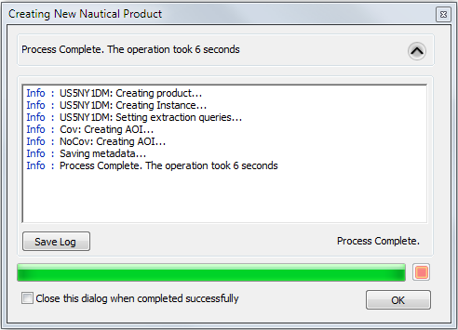

1. Click OK when the process completes.

You should now see the new product in the Product Library under the ***Tutorial*** series node. The product is now part of the ArcGIS for Maritime: Charting production system, and can be managed, modified and updated within it.

1. To export a New Edition of this product, follow the steps from ***Exercise 1: Exporting an ENC product***.

### Exercise 3: Importing an S-57 file, creating a new product, and exporting a New Dataset

Now that you have learned how to create and export products with the Product Library, this tutorial will show you how to bring your own S-57 data into ArcGIS. Once the S-57 data is imported to the NIS, it can be visualized, edited and used in ArcGIS. More importantly, you can start using ArcGIS for Maritime: Charting to edit the data, maintain the product, and export the future editions and updates of the product.

The process of bringing data into ArcGIS for Maritime: Charting for production involves two basic steps: Adding AOIs to the Product Library and Importing the S-57 dataset into the NIS geodatabase. In this exercise, you may use the ENC provided with the tutorial (NOAA ENC US4HA51M) or you may use a cell of your own. The cell must be decrypted in order to import it into the geodatabase.

#### Importing S-57 data into the geodatabase

Before you can export data from the NIS, the NIS needs to be populated with data. There are a variety of ways to get data into the NIS, including compilation from geo-referenced paper charts, or through a wide range of data mapping and migration methods. For the purpose of this tutorial, you will be using S-57 data to populate the NIS.

1. Open Catalog by clicking Windows > Catalog from the main menu.
2. In the ***Catalog*** window, Expand Toolboxes > System Toolboxes > Nautical Tools.
3. Double-click **Import S-57 to Geodatabase**.

The Import S-57 to Geodatabase geoprocessing tool appears.

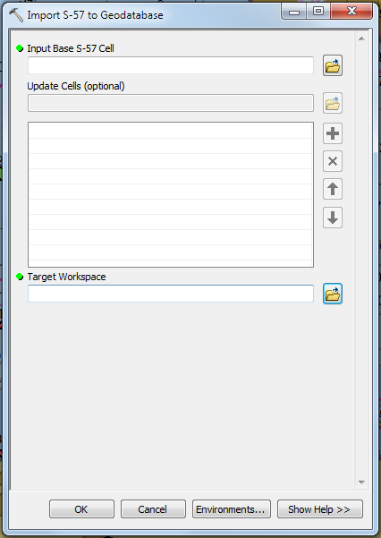

1. Click the folder icon under Input Base S-57 Cell.
2. Browse to the location of your S-57 file, or use the NOAA cell, US4HA51M.
3. If you have Update Cells, you may browse to and select those as well using the Update Cells parameter. US4HA51M has 6 available updates.
4. For Target Workspace, browse to the location of the ***TUTORIAL_NIS.gdb***.

Your Import S-57 to Geodatabase dialog should be similar to the following image:

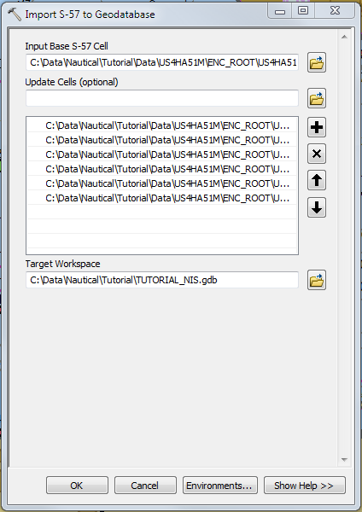

1. Click OK.

A process dialog appears logging the features mapped to the geodatabase.

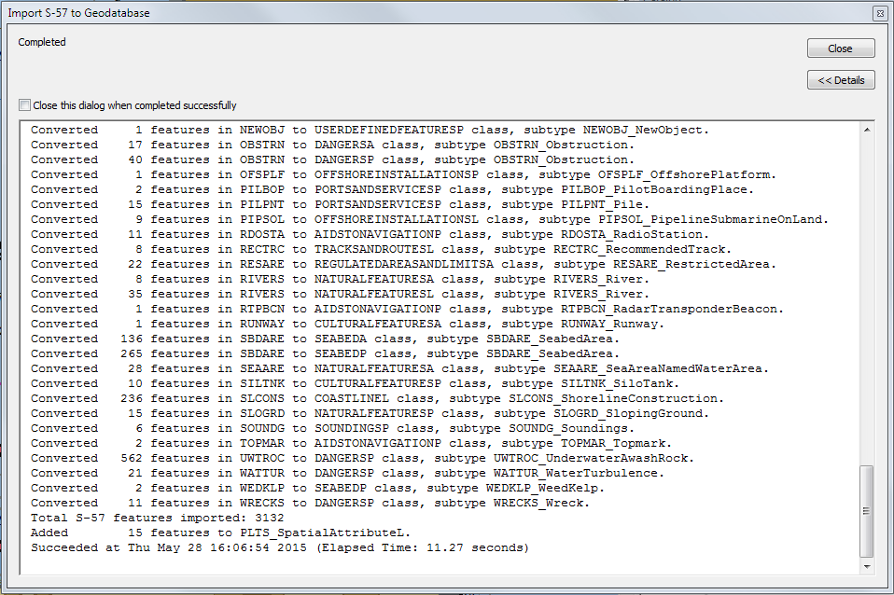

1. Click Close.

You have now loaded S-57 data into the GIS.

Notes on Import S-57 to Geodatabase:

If you do not want to create and update products using ArcGIS for Maritime: Charting, you can stop here, and simply use the geoprocessing tool as a means to bring your data into a fully functional GIS for analysis, services, or simply to be used as ‘just another data source’ for a wide range of purposes. This would mean that all the previous steps in the entire tutorial, including the setup, could be ignored. The Import S-57 to Geodatabase tool provides a simple means of exposing the rich content available in maritime data to the power of GIS.

#### Adding AOIs to the Product Library

In order to use ArcGIS for Maritime: Charting as a production system, after importing S-57 data to the NIS, you will also need to populate the product library with AOIs to support creating and exporting S-57 products.

1. Add the PL AOI Loader tool to a toolbar.
   1. From the main menu, click Customize > Customize Mode.
   2. Click the **Commands** tab.
   3. Click the **Nautical category**.

Tip:

You can also type PL AOI Loader in the Search box.

* 1. Drag the **PL AOI Loader** tool to a toolbar.
  2. Click Close.

1. Click the PL AOI Loader button.

The ***PL AOI Loader*** dialog box appears.

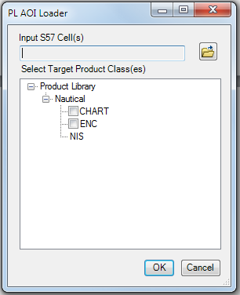

1. Click the browse button next to Input S57 Cell(s).

The ***Open*** dialog box appears.

1. Select at least one cell. If you used the data provided by the tutorial, you would point to the US4HA51M cell – if you are using your own data, point to that cell.

You can load more than one cell; each cell will result in a corresponding AOI in the Product Library.

1. Click Open.
2. Check the ENC checkbox.
3. Click OK.
4. Click OK on the Process Complete dialog box.

The M_COVR features were loaded into the product library and can now be used as AOIs by the New Nautical Product wizard.

1. Repeat the steps from ***Exercise 2: Creating a new ENC product and exporting a New Edition*** to complete the tutorial.

### Tutorial Summary

Congratulations, you have successfully learned how to bring S-57 data into the geodatabase, how to create products in the Product Library, and how to export that data back out to the S-57 format.

ArcGIS for Maritime: Charting provides powerful and easy to use tools to accomplish your goals, whether you need a complete production system for electronic and paper charts, or just a simple tool to bring maritime data into a true GIS. In the above exercises, you have used ArcGIS for Maritime: Charting in the context of a simple file-based system. The solution also supports more advanced implementation patterns and can be scaled up to a large enterprise production system using a variety of RDMS capable of supporting multiple editors simultaneously.

Of course, with ArcGIS, there is so much more you can do; from traditional desktop GIS analysis to sharing your geospatial data internally across your organization, or externally to the public via web services. To learn more about ArcGIS for Maritime: Charting, or to see how the ArcGIS platform can benefit you and your organization, please visit <http://www.esri.com/software/arcgis/extensions/maritime/charting> or contact [maritime@esri.com](mailto:maritime@esri.com).